
Color the bandana, then write three sentences explaining how you would feel wearing a bandana that matched everyone else’s on your sports team.
____________________________________________________________________________________________________________________________________________________________________________________________________________________________________________________________________________________________________________________________________________________________
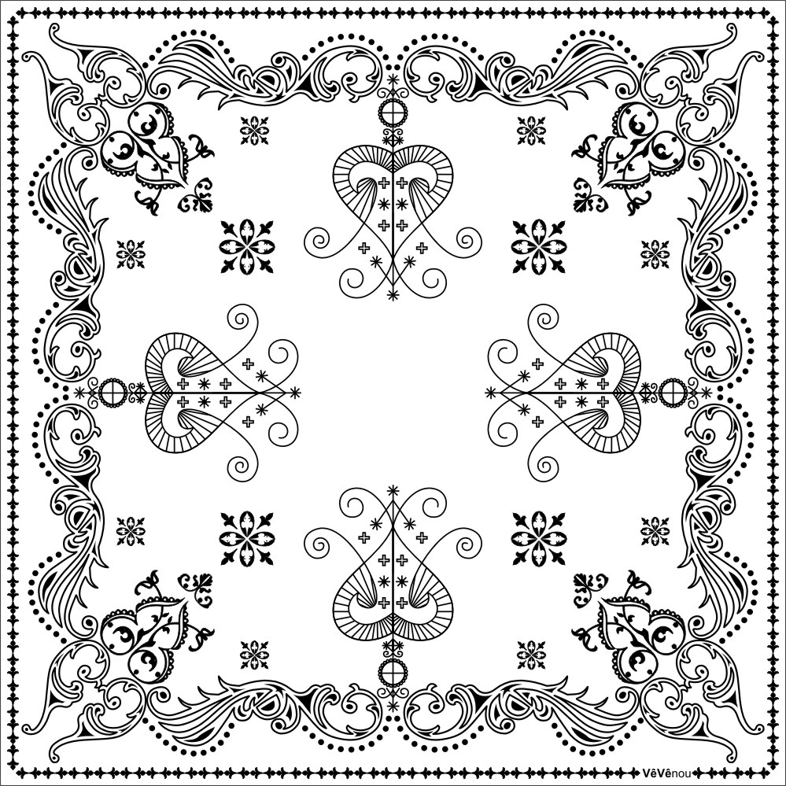
Ever notice how a BANDANA looks like a SUPERHERO CAPE?

Bandanas can help people feel BRAVE when they are going through something SCARY, just like a superhero cape! Use these examples or draw your own bandana or superhero cape!



